Soviet Union Falls Apart

- 1991 Soviet Union collapsed and created:
1. Armenia, 2. Azerbaijan, 3. Belarus, 4. Estonia, 5. Georgia, 6. Kazakhstan, 7.Kyrgyzstan, 8. Latvia, 9. Lithuania, 10. Moldova, 11. Russia,
12. Tajikistan, 13. Turkmenistan, 14. Ukraine, 15. Uzbekistan

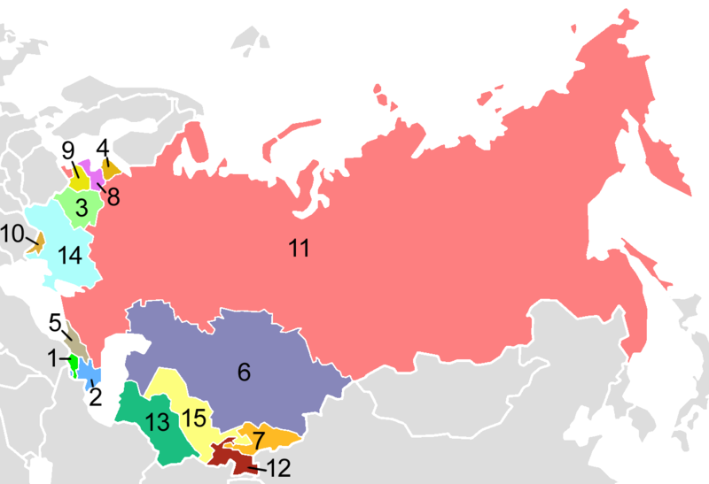

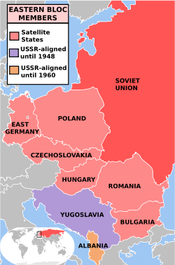

- Iron Curtain/Soviet Bloc included: East Germany,
Poland, Czechoslovakia, Hungary, Romania, Bulgaria,
Yugoslavia, and Albania

- East Germany = reunified with West Germany in 1990 and became Germany
- Czechoslovakia = Czech Republic and Slovakia
- Yugoslavia = Bosnia and Herzegovina, Croatia, Macedonia, Montenegro, Serbia, Slovenia, and Kosovo

